Feedbacks for ticket PGMPLPS-262
- Mobile: The 2 icons for HTML Factsheet & Charting Tool are not left aligned like other items on top of it. There is some space left on the left side. This applies to all the tabs.
Page link: https://phoenixlife.co.uk/site-services/fe-fund-hub
Devices: iPhone 15 Pro Max, Samsung Galaxy S24
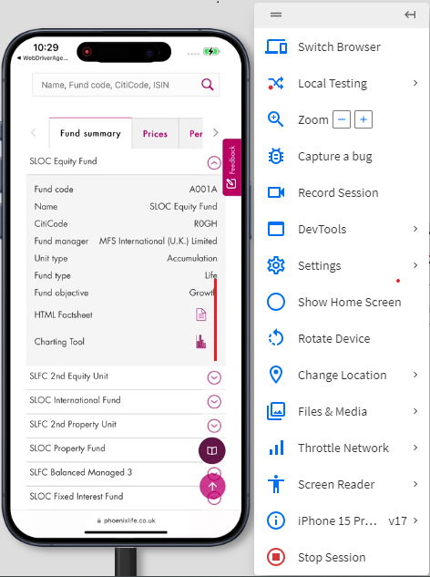
- Mobile: The snapdown icons on the left size of the list for Charges tab are furthermore towards right side compared to other tabs. They should be position little towards left for uniformity.
Page link: https://www.phoenixlife.co.uk/site-services/fe-fund-hub
Devices: iPhone 15 Pro Max, Samsung Galaxy S24
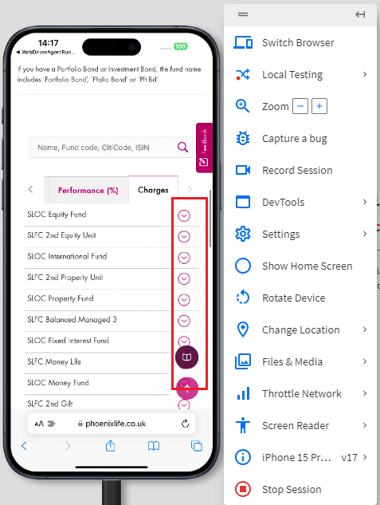

- Mobile & Tablet: In landscape orientation, the text and icons for HTML Factsheet & Charting Tool are overlapping. This issue is also encountered on tablet.
Page link: https://phoenixlife.co.uk/site-services/fe-fund-hub
Devices: iPhone 15 Pro Max, iPad Air 5
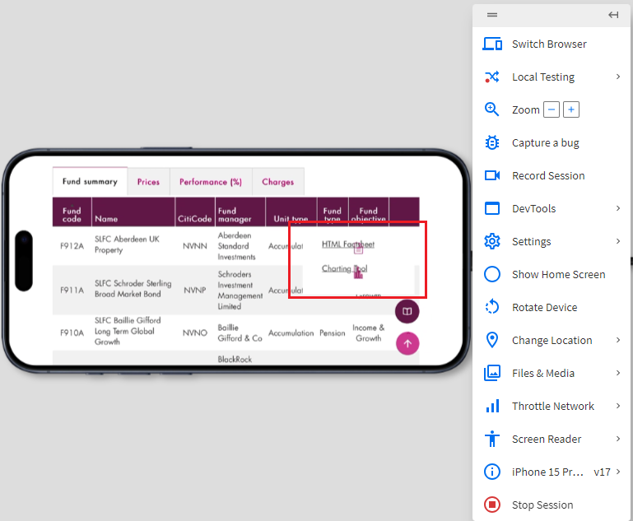

- Mobile & Tablet: For text edit box in search back, if the name is long e.g. SLFC Schroder Sterling Broad Market Bond, then there’s no breathing space between text and search icon. This issue is Also encountered on tablet.
Page link: https://phoenixlife.co.uk/site-services/fe-fund-hub
Devices: iPhone 15 Pro Max, iPad Air 5, Samsung Galaxy S24
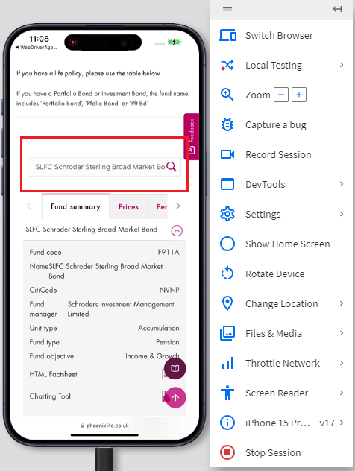
- Mobile: If the name is long e.g. SLFC Schroder Sterling Broad Market Bond, then the Name content after opening the snapdown doesn’t have proper spacing and alignment.
Page link: https://www.phoenixlife.co.uk/site-services/fe-fund-hub
Devices: iPhone 15 Pro Max, Samsung Galaxy S24
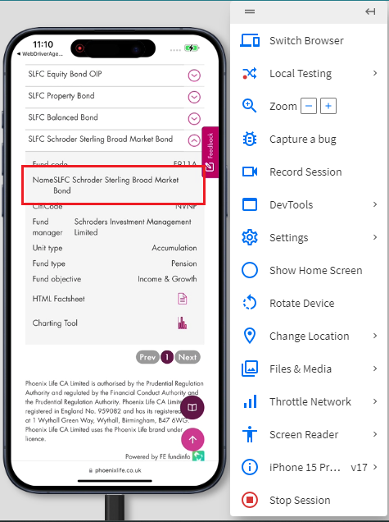

- Mobile: Values for the last column on Factsheet page falls into new line and last column is shown blank.
Page link: https://staging-digital.feprecisionplus.com/factsheethtml/sloc/en-gb/SLOC/?TypeCode=FC:R0GH&specialunittype=ORDN&MPCategoryCode=&Category=&priipproductcode=&documentcountry=&Category2=
Devices: iPhone 15 Pro Max, Samsung Galaxy S24
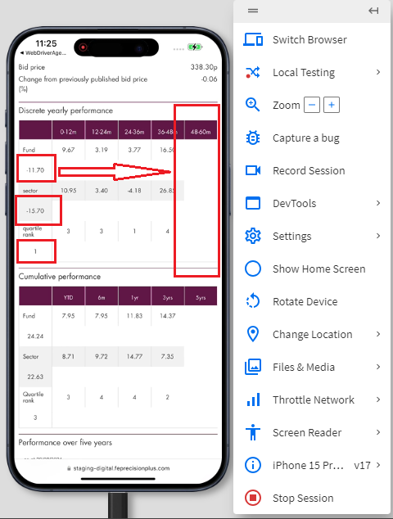
- Mobile: The tabs Cumulative performance (%) & Discrete performance (%) can be of the same size since there are only 2 tabs. Also, the left and right arrow icons besides these tabs can be removed too.
Page link: https://staging-digital-tools.feprecisionplus.com/sloc/charting/en-gb/SLOC?TypeCode=FC:R0GH&specialunittype=ORDN&MPCategoryCode=&Category=&priipproductcode=&documentcountry=&Category2=
Devices: iPhone 15 Pro Max, Samsung Galaxy S24
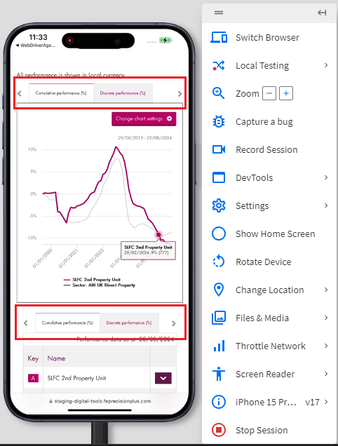

- Tablet: There should be padding on left and right ends of the Factsheet page in landscape orientation.
Page link: https://staging-digital.feprecisionplus.com/factsheethtml/sloc/en-gb/SLOC/?TypeCode=FC:R0GH&specialunittype=ORDN&MPCategoryCode=&Category=&priipproductcode=&documentcountry=&Category2=
Device: iPad Air 5
